Jousting Robot Senior Project
With Wireless Controller

Senior Project Final Documentation
Ximing He
April 20, 2017

Contents
Abstract 3
Introduction 3
Background 5
Project Documentation 9
Project Performance 11
Project Limitations 12
Project Demonstration / Operation 13
Ethical and Safety Concerns 14
Summary and Conclusions 14
Acknowledgments 15
Bibliography and References 15
Appendix A – Wireless Controller Code 16
Appendix B – Robot Body Code 17

Abstract
This Jousting Robot Project is a simulation of medieval jousting using a pair of robots with full mobility and lance maneuvers. Two players manipulate the robot movement, both the moving base and swinging lance, via the wireless controller, to compete against the opponent robot. The player-controlled robot wields the lance to knock the knight (doll) out of the opponent’s robot.

Introduction
The main idea of this project is to build a pair of remotely-controlled Jousting Robot prototypes for recreational use. It mimics the competition of medieval jousting.
A pair of robots represent two cavalries in the competition. A knight doll stands on the robot body, representing the knight on the horseback. A five-inch long stick is attached on the prototype, representing the lance. The robot base has full mobility, including going straight forward and back, turning left and right. Its left- and right-turning include rotating at the same point and turning in a circle. The lance has a semispherical movement mobility. It can swing up-down and left-right. The moving base and swinging lance receive distinct commands, which means the movements will not interfere each other, i.e. the base can be going front or back while the lance swings, and vice versa.
The initial idea of robot competition of this project comes from a robot fighting scene of movie Big Hero 6. It provokes me from thinking that, as an electrical engineer, I should be able to build a fighting robot like the ones in the movie. Besides, if the actual prototype of my design can be built and introduced to school students, their interest of studying might be aroused, too. My project can be an introduction for those who have interest studying in electrical engineering.
The project should not be focusing merely fighting, which might be brutal for children. The project should include other educational purposes such as historical awareness. Medieval jousting is a good entry. It is a kind of competition that we hardly practice it in the modern society, but it is a kind of combat that has its historical prevalence. Moreover, jousting is a simple practice. The rules are clear: the horsemen strike the opponents and try to unhorse him. It is straightforward to mimic jousting on the robots. Therefore, building jousting robots for competition meets my project intention, educational attention, and physical possibility.
The robots are controlled wirelessly. This is the modern requirement for any handheld devices. A pair of RF embedded modules transmitter and receiver are used for the wireless communication.
On the controller, three push buttons control the moving base, and one joystick controls the swinging lance. The controller is powered through USB interface; the robot body is powered by AA batteries.

Background
In jousting competition, there are three major components: knight, lance, horse. The knight is the emblem to indicate the competition status. The fall of the knight signifies the lost. In this project, the knight is imitated by a three-inch tall doll.
The lance is the weapon to perform the attack. This long weapon is used to poke and unhorse the opponent. In this project, the lance is imitated by a five-inch long plastic stick.
The horse is the mount to perform the movement. It makes the cavalry to go anywhere. In this project, the horse is imitated by a two-wheel chassis. For assembly simplicity, I choose Parallax Inc.’s Boe-Bot® chassis for this project. The chassis includes two servo motors and wheels, a battery holder, and a tail wheel. Figure 1 to Figure 4 show the process of assembling the Boe-Bot® chassis.
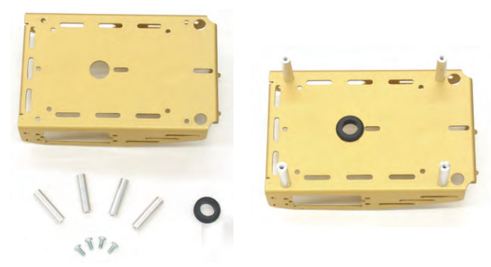
Figure 1
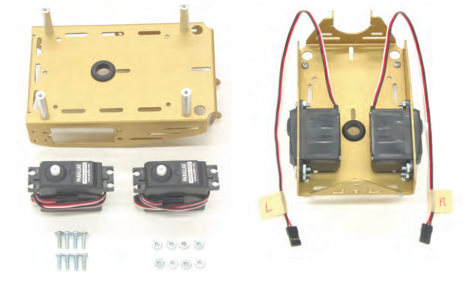
Figure 2
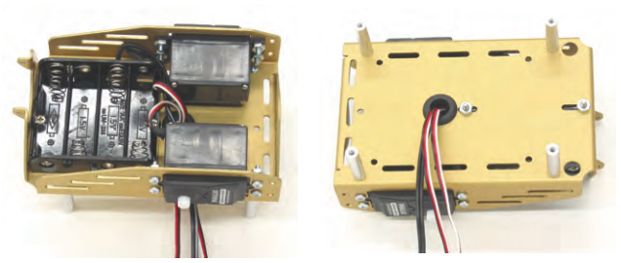
Figure 3
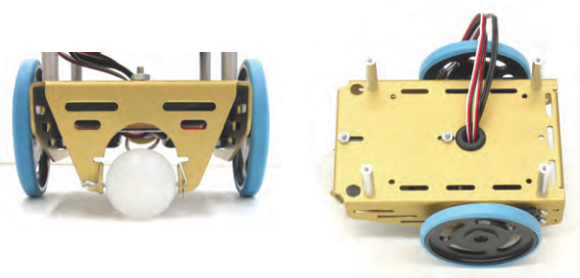
Figure 4

This project is based on Arduino. Arduino is an open-source platform that created microcontroller-based kits for building digital devices and interactive objects that can sense and control physical devices. The Arduino UNO boards used in this project have reasonable small size, 53.4 × 68.6 mm. It is a convenient way to start small projects, and it is easy to use.
Digi XBee® is used for the wireless communication part of this project. XBee® is the initial point-to-point topology or star topology module running the IEEE 802.15.4 protocol.
Arduino uses serial communication. Data are sent as characters through XBee®. That’s why I come up with a technique of transmitting data using ASCII value of characters. In the early version of my design, the wireless controller use only push buttons instead of joysticks. In the push-button version prototype, I only either send out 0 (button not pushed) or 1 (button being pushed) for each push button. In the joystick version prototype, analog signals are sent. I can make the sender transmit different char values based on the level of joystick being pushed. ASCII code can still work for analog signals, but it is limited from 0 to 126. I can map the signals from joystick (0~1023) to 0~126 as I do not need that full 1024 levels anyways.
The inner circuit of Parallax 2-Axis Joystick is shown in Figure 5 below.
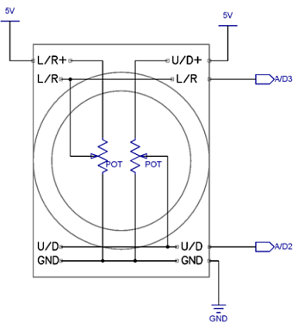
Figure 5
According to the data sheet, the Parallax joystick contains two 10 kΩ potentiometers, one for each axis. The joystick controls the swinging lance, which consists of two servos. There are two outputs from joystick, which are two inputs of Arduino board. Arduino board receives the values from joystick. This values, which are numbers, are sent, through XBee®, to the servos, and the servos will point to the exact position.

Project Documentation

Arduino Configuration
Arduino microcontrollers are programmed using a dialect of features from C/C++ language. The codes should be developed using Arduino Software, which can be downloaded at Arduino.cc. Figure 6 shows a screenshot of programming in Arduino software. The final codes of this Jousting Robot Project are attached in the Appendix.
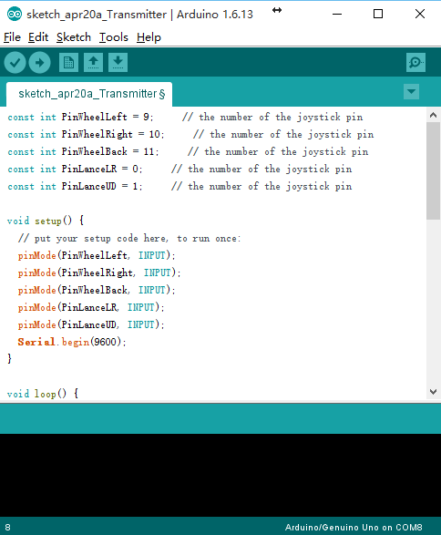
Figure 6

XBee® Configuration
XCTU software is require for configuration of XBee®. The software can be downloaded at digi.com. For simplicity, the two pairs of XBee® used in this project are both configured as End Devices in AT mode. In this demo, the wireless communication is not encrypted. Figure 7 shows a screenshot of configuring XBee® in XCTU software.
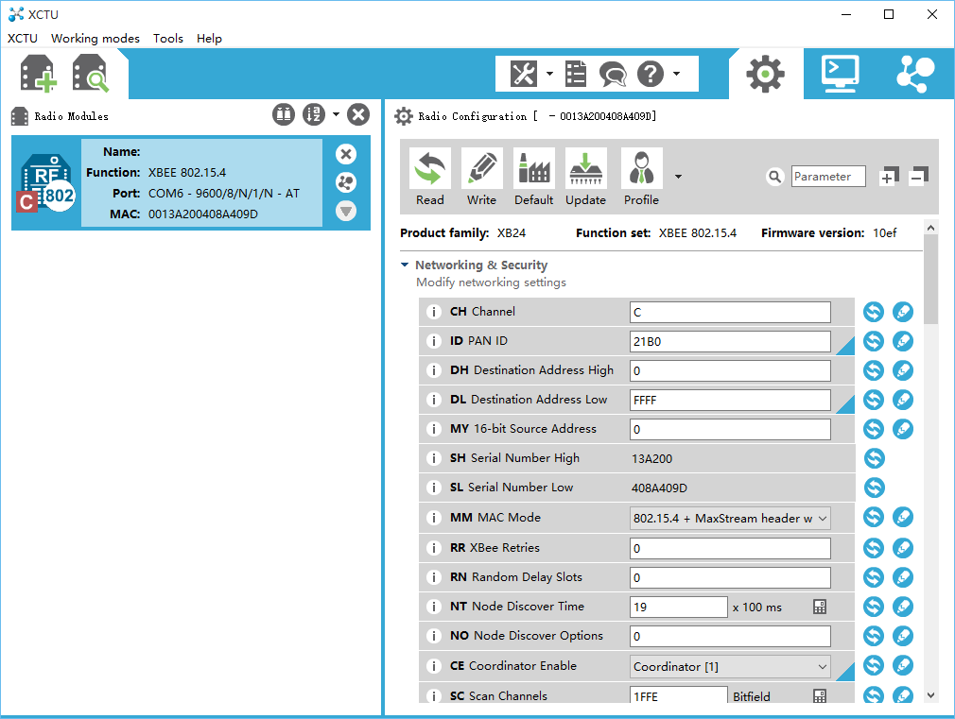
Figure 7

Components & Parts Cost
Robot Body
Arduino UNO board | 1 × $20
Digi XBee® 802.15.4 | 1 × $20
XBee® Adapter | 1 × $10
Servo Motor | 4 × $5
Robot Body Base Frame | 1 × $10
Knight doll | 1 × $5
Battery Holder | 1 × $5
Battery | 4 × $2
Total Cost | $98
Figure 8
Wireless Controller
Arduino UNO board | 1 × $20
Digi XBee® 802.15.4 | 1 × $20
XBee® Adapter | 1 × $10
Breadboard | 1 × $5
Push Buttons | 3 × $1
Joystick | 1 × $10
10 kΩ Resistor | 3 × $1
Total Cost | $71
Figure 9
Figure 8 and Figure 9 involve only one set of Jousting Robot. The estimate total cost is $169. To set up a competition, at least two sets of Jousting Robot are needed.

Project Performance
The robot base has full mobility, including going straight forward and back, turning left and right. Its left- and right-turning include rotating at the same point and turning in a circle.
The lance has a semispherical movement mobility. It can swing up-down and left-right, both within 180 degrees. However, in the final design, I limit the swinging angle to 113 degrees because of two reason. First, the lance is so long comparing the size of the prototype. The lance can swing and touch the ground. If it goes further, the robot base will be lifted. In this case, the base could not perform its movement accordingly. I need the lance to be long as it is the weapon to poke the opponent. Second, the lance is attached directly to the robot body. If the lance has full 180-degree horizontal turning, which the servo can offer, the lance will hit the robot base wheels. Even though I limit the movement of the lance, it can still have enough mobility to perform the poking.
The moving base and swinging lance receive distinct commands, so the movements of the base and lance can be performed simultaneously without any interference.

Project Limitations
Three push buttons control the movement of the robot base. The data sent are either 0 or 1, which control the continuous rotation servos either stop or move. There is no speed control for it in this version of my design.
Components are attached together using super glue. It is not an ideal solution for assembly. If more time and resources are provided, the profile of the robot and the controller can be designed using 3D modeling software, such as Fusion 360. The model can be printed out using 3D printer.

Project Demonstration / Operation
There are three push buttons and one joystick on the controller for the user to manipulate the robot. Figure 10 shows the controller manual.
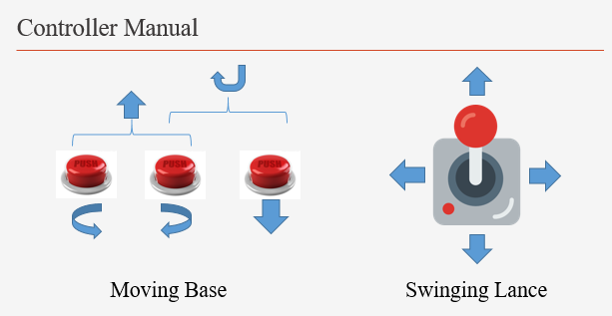
Figure 10
As indicated in the manual, the first push button makes the robot base turn left; the second one makes it turn right; the third one makes it go backward. If the first two buttons are pushed simultaneously, the robot will go straight forward. If the first and third buttons are pushed simultaneously, it will go backward clockwise in a circle. If the second and third buttons are pushed simultaneously, it will go backward counterclockwise in a circle. I did not design special movement for all three buttons are pushed at the same time. In such a case, the robot simply go straight forward, the same movement when only the first two buttons are pushed simultaneously.
The lance movement is straightforward. The lance will point to the exact angle where the joystick is pointing to.

Ethical and Safety Concerns
This project is a simulation of medieval jousting. It is for recreational use. The target users/players are teenagers or older who would like to get a sense on remotely-controlled electronic gadgets, who would like to compete, and have fun. The idea of jousting is not a stimulation of violence but a reminiscence of history.
The robot is powered by AA batteries. The power generated by those batteries will not seriously harm human bodies. However, the waste of batteries might negatively impact the environment. Using rechargeable batteries would minimize this issue.
The components used in this Jousting Robot project are common electronic devices. Those parts can be disassembled and used in other occasions. If this project is brought into manufacture, the product layout should be redesigned to a more proper way, but the parts and components are still common electronic elements.

Summary and Conclusions
In this Jousting Robot with Wireless Controller project, I successfully develop, from software to hardware, from information research to physical implementation, a working demo. The prototype mimics medieval jousting competition. The robot base and lance have full mobility and function well. The robot can be controlled wirelessly without interruption. The rules of the competition are straightforward. This project is presented in varied occasion and demonstrated to different personnel and levels. Therefore, it is a stable design project.

Acknowledgments
Professor Craig Christensen offers the Parallax Inc.’s Boe-Bot® chassis. Boe-Bot® is the robot kit used in robotics classes. Also, Christensen is the professor who oversees the Senior Project course.
Professor Mostapha Ziad introduce Arduino, an open-source electronics platform, to me in Embedded Systems course. I used this platform as the basic of my design. Also, Professor Ziad suggest I use XBee® for the wireless communication part in this project.

Bibliography and References
Robotics with the Boe-bot: Student Guide. N.p.: Parallax, 2010. Robotics with the Boe-Bot Student Guide. Web. 10 May 2017. <https://www.parallax.com/sites/default/files/downloads/28125-Robotics-With-The-Boe-Bot-v3.0.pdf>.
"Arduino - Introduction." Arduino - Introduction. N.p., n.d. Web. 07 Dec. 2016. <https://www.arduino.cc/en/guide/introduction>.
"XBee: Connect Devices To The Cloud - Digi International." XBee: Connect Devices To The Cloud - Digi International. N.p., n.d. Web. 07 Dec. 2016. <https://www.digi.com/lp/xbee>.
"Learn.parallax.com." Joystick. N.p., n.d. Web. 05 Mar. 2017. <http://learn.parallax.com/tutorials/language/propeller-c/propeller-c-simple-devices/joystick>.
"XCTU." XCTU - Next Gen Configuration Platform for XBee/RF Solutions. Digi International, n.d. Web. 10 May 2017. <https://www.digi.com/products/xbee-rf-solutions/xctu-software/xctu>.

Appendix A – Wireless Controller Code
const int PinWheelLeft = 9; // the number of the joystick pin
const int PinWheelRight = 10; // the number of the joystick pin
const int PinWheelBack = 11; // the number of the joystick pin
const int PinLanceLR = 0; // the number of the joystick pin
const int PinLanceUD = 1; // the number of the joystick pin
void setup() {
// put your setup code here, to run once:
pinMode(PinWheelLeft, INPUT);
pinMode(PinWheelRight, INPUT);
pinMode(PinWheelBack, INPUT);
pinMode(PinLanceLR, INPUT);
pinMode(PinLanceUD, INPUT);
Serial.begin(9600);
}
void loop() {
// put your main code here, to run repeatedly:
short myData[] = {0, 0, 0, 0, 0, 0};
myData[1] = digitalRead(PinWheelLeft);
myData[2] = digitalRead(PinWheelRight);
myData[3] = digitalRead(PinWheelBack);
myData[4] = analogRead(PinLanceLR);
myData[5] = analogRead(PinLanceUD);
char myChar[] = {'@', 'A', 'A', 'A', 'A', 'A'};
myChar[1] = map(myData[1], 0, 1, 0, 126);
myChar[2] = map(myData[2], 0, 1, 0, 126);
myChar[3] = map(myData[3], 0, 1, 0, 126);
myChar[4] = map(myData[4], 0, 1023, 0, 126);
myChar[5] = map(myData[5], 0, 1023, 0, 126);
/*
for (byte i = 0;i < 6; i++){
Serial.print(myData[i]);
Serial.print(", ");
}
Serial.println("");
*/
for (byte i = 0;i < 6; i++){
Serial.print(myChar[i]);
//Serial.print(", ");
}
Serial.println("");
delay(100);
} // end void loop()

Appendix B – Robot Body Code
#include <Servo.h> // servo library

Servo servoWheelLeft; // Left wheel servo control object
Servo servoWheelRight; // Right wheel servo control object
Servo servoLanceLR; // Left arm servo control object
Servo servoLanceUD; // Left forearm servo control object
short lanceUD_Position = 90; // position for Servo arms
short lanceLR_Position = 90; // position for Servo arms
short myData[] = {0, 0, 0, 0, 0, 0, 33};

void setup() {
// put your setup code here, to run once:
servoLanceLR.attach(9);
servoLanceLR.write(lanceLR_Position);
servoLanceUD.attach(10);
servoLanceUD.write(lanceUD_Position);
servoWheelLeft.attach(11);
servoWheelLeft.write(90);
servoWheelRight.attach(12);
servoWheelRight.write(90);
Serial.begin(9600);
}

void loop() {
// put your main code here, to run repeatedly:

if (Serial.available() > 6){
if (Serial.read() == 64){
for (int i=0;i<5;i++){
myData[i] = Serial.read();
// Serial.print(myData[i]); // for debug
// Serial.print(", "); // for debug
}
// Serial.println(""); // for debug

wheelMove(myData[0], myData[1], myData[2]);

// Lance movemont from here, UD = 0~180, LR = 0~180
// Joystick on Controller rotated 90 degree clockwise
lanceUD_Position = map(myData[3], 10, 123, 40, 153);
lanceUD_Position = constrain(lanceUD_Position, 0, 180);
servoLanceUD.write(lanceUD_Position);
// Serial.print(lanceUD_Position); // for debug
// Serial.print(", "); // for debug
lanceLR_Position = map(myData[4], 10, 123, 180, 0);
lanceLR_Position = constrain(lanceLR_Position, 0, 180);
servoLanceLR.write(lanceLR_Position);
// Serial.print(lanceLR_Position); // for debug
// Serial.print(", "); // for debug
// Serial.println("\n"); // for debug
while(Serial.available()) Serial.read();
} // end if (Serial.read() == 64)
} // end if (Serial.available() > 6)
} // end void loop()

void wheelMove(int left, int right, int back){
// wheelLeft forward = 180
// wheelRight forward = 0
if(left > 100 && right > 100){ // forward
servoWheelLeft.write(180);
servoWheelRight.write(0);
}
else if (left < 20 && right > 100 && back < 20){ // right turn
servoWheelLeft.write(180);
servoWheelRight.write(180);
}
else if (left > 100 && right < 20 && back < 20){ // left turn
servoWheelLeft.write(0);
servoWheelRight.write(0);
}
else if (left < 20 && right < 20 && back > 100){ // backward
servoWheelLeft.write(0);
servoWheelRight.write(180);
}
else if (left > 100 && right < 20 && back > 100){ // backward U-left
servoWheelLeft.write(90);
servoWheelRight.write(180);
}
else if (left < 20 && right > 100 && back > 100){ // backward U-right
servoWheelLeft.write(0);
servoWheelRight.write(90);
}
else{
servoWheelLeft.write(90);
servoWheelRight.write(90);
}
} // end int wheelMove(int wheelLR, int wheelUD)

https://youtu.be/3rdapDdgWGM
Robotics with the Boe-bot: Student Guide. N.p.: Parallax, 2010. Robotics with the Boe-Bot Student Guide. Web. 10 May 2017. <https://www.parallax.com/sites/default/files/downloads/28125-Robotics-With-The-Boe-Bot-v3.0.pdf>.
"Arduino - Introduction." Arduino - Introduction. N.p., n.d. Web. 07 Dec. 2016. <https://www.arduino.cc/en/guide/introduction>.
"XBee: Connect Devices To The Cloud - Digi International." XBee: Connect Devices To The Cloud - Digi International. N.p., n.d. Web. 07 Dec. 2016. <https://www.digi.com/lp/xbee>.
"Learn.parallax.com." Joystick. N.p., n.d. Web. 05 Mar. 2017. <http://learn.parallax.com/tutorials/language/propeller-c/propeller-c-simple-devices/joystick>.
"XCTU." XCTU - Next Gen Configuration Platform for XBee/RF Solutions. Digi International, n.d. Web. 10 May 2017. <https://www.digi.com/products/xbee-rf-solutions/xctu-software/xctu>.

